Kindergarten Art Projects
(a schedule for all clay projects across all grade levels needs to be created before we solidify the schedule for 1st grade, to ensure that every grade has priority over the use of the kiln and doesn’t overlap with other grade projects. November has typically been when Kindergarten goes)
October: Snow Owls
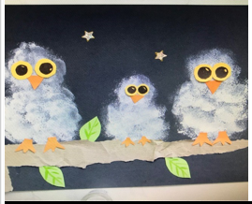
November: Clay Leaf Bowls
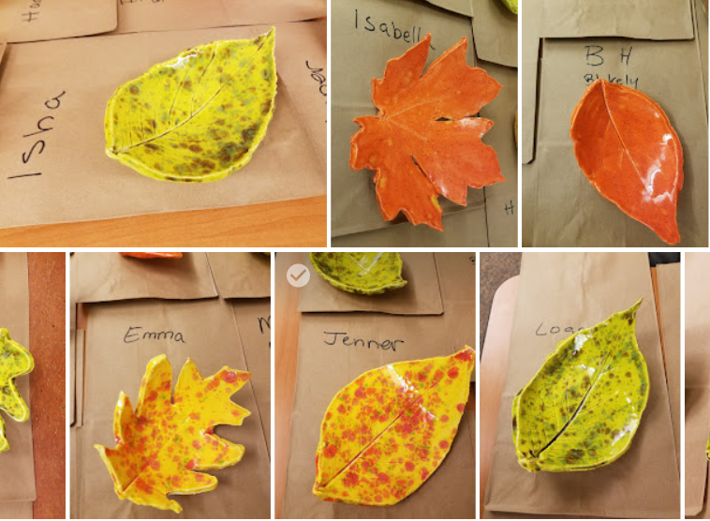
December: Penguin Presentation
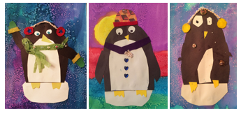
January: Color Mixing Dragons (great for Chinese New Year)
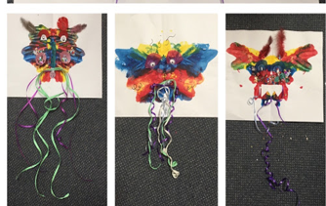
February: Henri Matisse Hearts
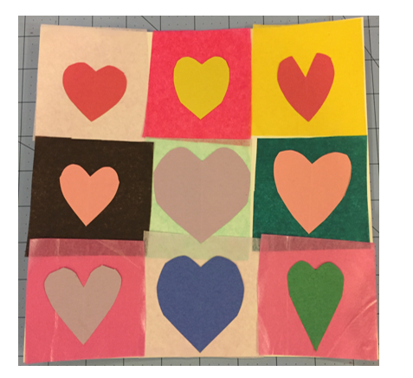
March: Positive Negative Space (stencils for Asian animals are available)
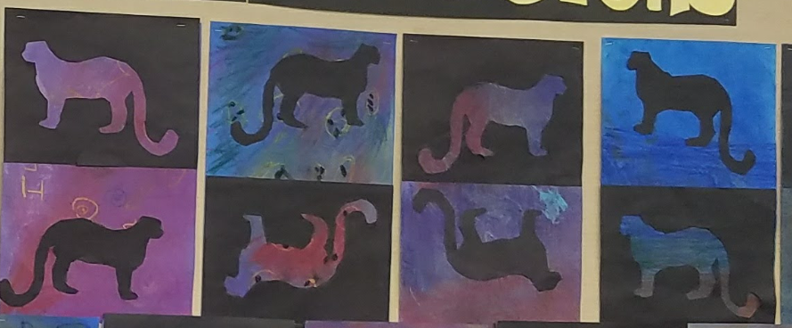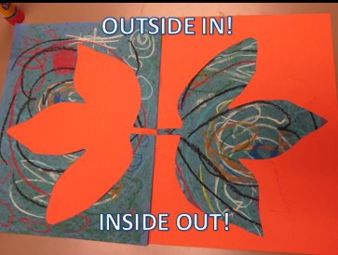
April: Japanese Carp Kites
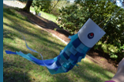

May: Self Portrait
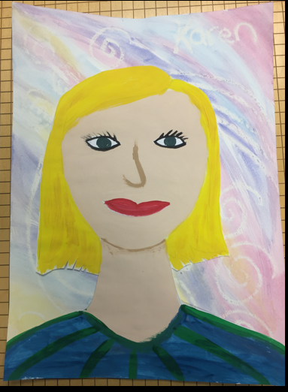
Other Projects:
Polar Bears at Night
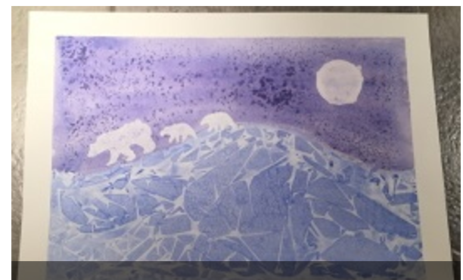
Andy Warhol Colorful Cats
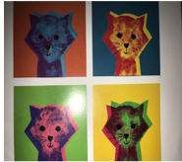
Birds on a Wire (geometric shapes, primary colors)
